**PERSON-CENTERED PLANNING: **

**What’s It All About?**  **Michigan Developmental Disabilities Council**

* ***Pre-Planning:* Is for the purpose of gathering the information and resources necessary for an effective PCP process and agenda**
* ***Wellness and Well-Being:* PCP highlights personal responsibility. The dignity of risk is honored**
* ***Participation of allies:* Through the pre-planning process, the person selects allies to support him or her through the process**

**Styles of planning should be individualized**

**There is no one, “right,” way of completing a PCP, as each focus person is a unique individual. Many different types of tools to assist with developing a person-centered plan exist. Some common examples of planning tools include:**

* **Planning Alternative Tomorrows with**

**Hope (PATH)**

* **Making Action Plans (MAPS)**
* **Essential Lifestyle Planning (ELP)**
* **Personal Futures Planning (PFP)**

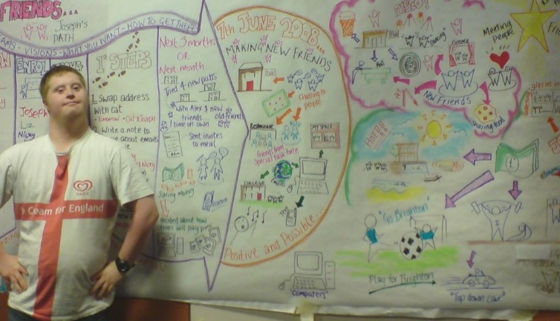

**All of these tools share common values and have similar steps. You can ask your case manager or support broker for more information about different types of planning tools and pick the one that works best for you. You may chose to develop your own tool that is ok. The planning tool you use is not as important as the outcomes of the plan.**

**Independent facilitation**





**What is Person-centered planning?**

**The Mental Health Code says supports must be delivered in a Person-centered way. Person-centered planning (PCP), is the entire process of planning and supporting the focus person, not just the written plan. PCP for minors is a family driven and youth guided practice that involves the whole family. For an adult, the planning process focuses on the person, not the system or person’s family, guardian, or friends.**

**Essential elements**

**There is no one, “right,” way of doing a PCP, as each focus person is a unique individual. There are however, some essential elements.**

* ***Person-Directed:* The person directs the planning process (with necessary support and accommodations), deciding when and where the meeting will be, and what will be discussed**
* ***Person-Centered:* The person’s goals, interests, desires, and choices are identified with a positive view of the future and plans for a meaningful life in the community**
* ***Outcome-based:* The person identifies outcomes to achieve in pursuing his or her goals. Progress is measured toward achievement of outcomes**
* ***Information, Support and Accommodations:* The person receives complete and unbiased information on services and supports available, community resources and options for providers. Accommodations are made for understanding**
* ***Independent Facilitation:* Individuals have the information and support to choose an independent facilitator to assist them in the planning process**

**For information or questions contact the Developmental Disabilities Council at: (517) 335-3158, or on the web at: www.michigan.gov/ddcouncil**

8/17