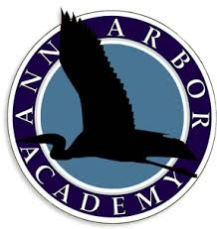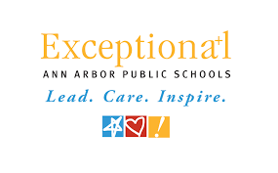

*For more information please contact John Boshoven at*

*boshoven@aaps.k12.mi.us*

*Building Bridges For Students Who Learn Differently*

Sponsored by Ann Arbor Public Schools and Ann Arbor Academy

*Bringing students from throughout Southeastern Michigan together with colleges and organizations that provide special resources for students with learning challenges*

Thursday, October 25th, 2018

6:30 PM – 8:00 PM

Huron High School

2727 Fuller Road

Ann Arbor, Michigan 48105

Please join us for the 7th annual

Ann Arbor College & Transition Services Fair