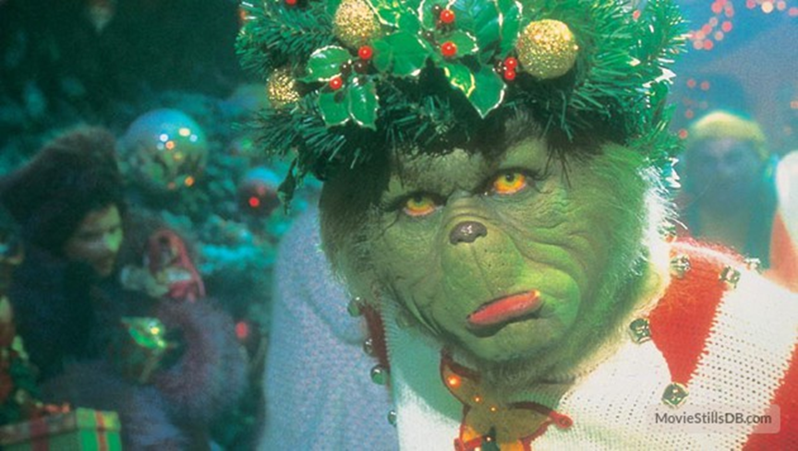

How the Grinch Stole Christmas
Come and watch the movie “The Grinch”- wear your jammies and bring your favorite blanket!
When: December 10, 2016 from 7:00-9:00pm
Where: Saline Middle School Auditorium
Cost: $3.00 per person
There will be a drawing for prizes. Refreshments can be purchased before and during the movie.
Sponsored by the SEAC committee

