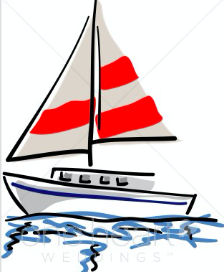

New from Area 20 Washtenaw Special Olympics FB page regarding Special Olympics Sailing:
We have an exciting opportunity! Area 20 will be offering Sailing if there is enough interest! For this year it would be an exhibition event for Fall Games.
If anyone is interested in participating in the sailing please email Mary Johanson at coachmaryjohanson@gmail.com ASAP.
Practices would be Monday evenings at Portage Lake Yacht club in Pinckney...6:00-7:30pm, possibly to 8pm.

