Resources

Sample Tweets
Proudly partnering with @MICivilRights to help identify the needs of the Deaf, DeafBlind and Hard of Hearing communities with the NotWithoutUsMich.org survey. #NotWithoutUsMich
Let’s help make Michigan more inclusive by encouraging our friends and family who are Deaf, DeafBlind and Hard of Hearing to take the survey at NotWithoutUsMich.org. #NotWithoutUsMich

Drop-in Newsletter Article
If you are part of an organization with a newsletter, you can include this article prepared by the DODDBHH. Additional graphics are available to use to accommodate your layout.
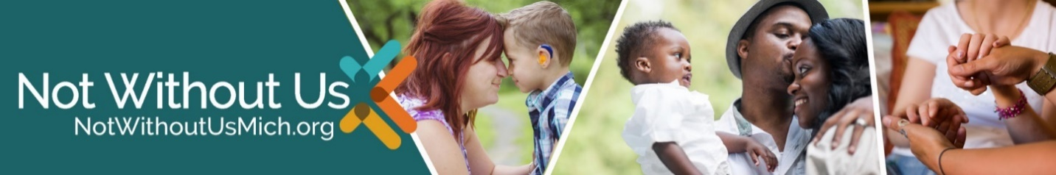
Help Make History
For the first time since 1989, The Michigan Department of Civil Rights, or MDCR, Division on Deaf, DeafBlind and Hard of Hearing has launched a historic and comprehensive needs assessment for the people they serve.
It’s an online survey, available on the Not Without Us website, and it is open until mid-November. The survey is available for anyone 13 years of age and up who is Deaf, DeafBlind or Hard of Hearing, or anyone who is a caregiver for those who are under age 13.
“As we work to make Michigan the most accessible state in the country, we also need to know where the barriers and opportunities are for individuals who are Deaf, DeafBlind and Hard of Hearing,” said Annie Urasky, director of the DODDBHH. “By sharing the survey with your friends, family and social networks, you will help us assist impacted communities by providing us with a clear snapshot of their needs. With the snapshot, we can make the case with decision makers throughout Michigan for how best to meet those needs.”
The survey was designed with the input of a steering committee made up of persons from the Deaf, DeafBlind and Hard of Hearing communities. In addition to holding community events to promote the survey, the DODDBHH and MDCR have been using social media to push #NotWithoutUsMich and the Not Without Us website to increase community engagement. For more information on the project, contact info@NotWithoutUsMich.org.

Sample Facebook Posts
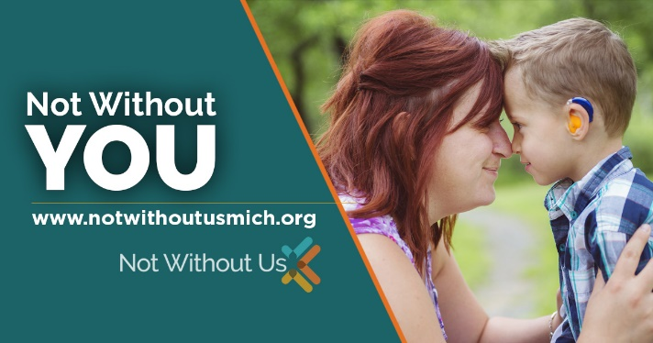
Accessing services shouldn’t be a burden or a frustration. That’s why we’re pleased to join with the Michigan Department of Civil Rights Division on Deaf, DeafBlind and Hard of Hearing to seek your input on what the obstacles and opportunities are for the communities they serve. Please share this historic survey, accessible at NotWithoutUsMich.org, with your friends, clients, neighbors and family members who are members of the Deaf, DeafBlind and Hard of Hearing communities.
OR
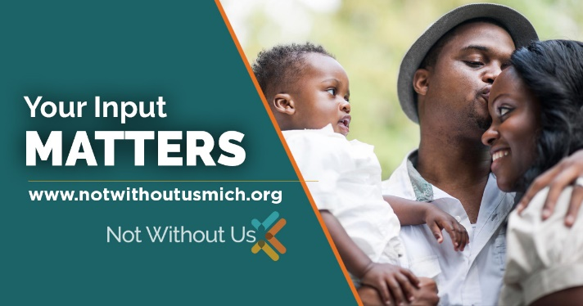
If you are a member of the Deaf, DeafBlind or Hard of Hearing communities, now is the time to help inform lawmakers and decision makers what you need to be able to communicate effectively and live your best life! Take the Not Without Us survey today. There’s a bonus too—when you’re done with the survey, you can request your own personal referral code. When your friends take the survey and enter your code, you become eligible for prizes

