Saline Middle School Needs YOU!
Volunteer for the 7th Annual SMS Career Day!
Show case your career with eager students and staff at this annual event
ALL Careers needed!

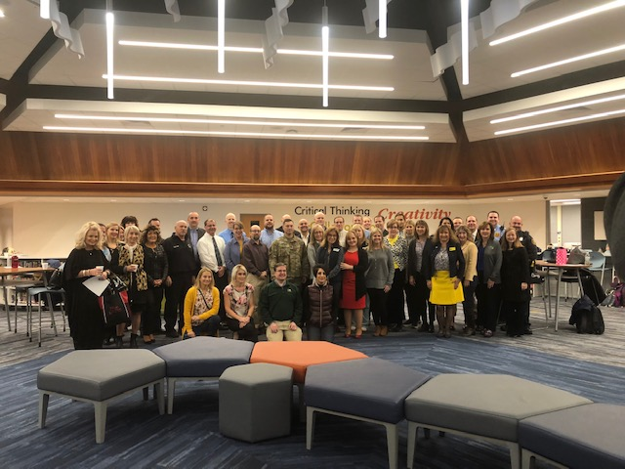

Wednesday, November 6, 2019
7:30am-10:30am

Sign up today!!! (link)

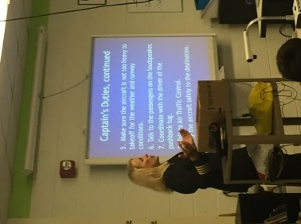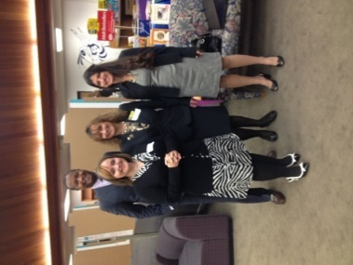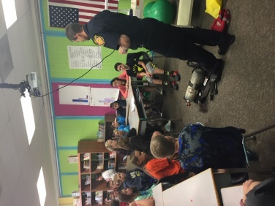
Questions, please reach out to Kim Bryant at kjbryant@umich.edu or 734-645-9691

