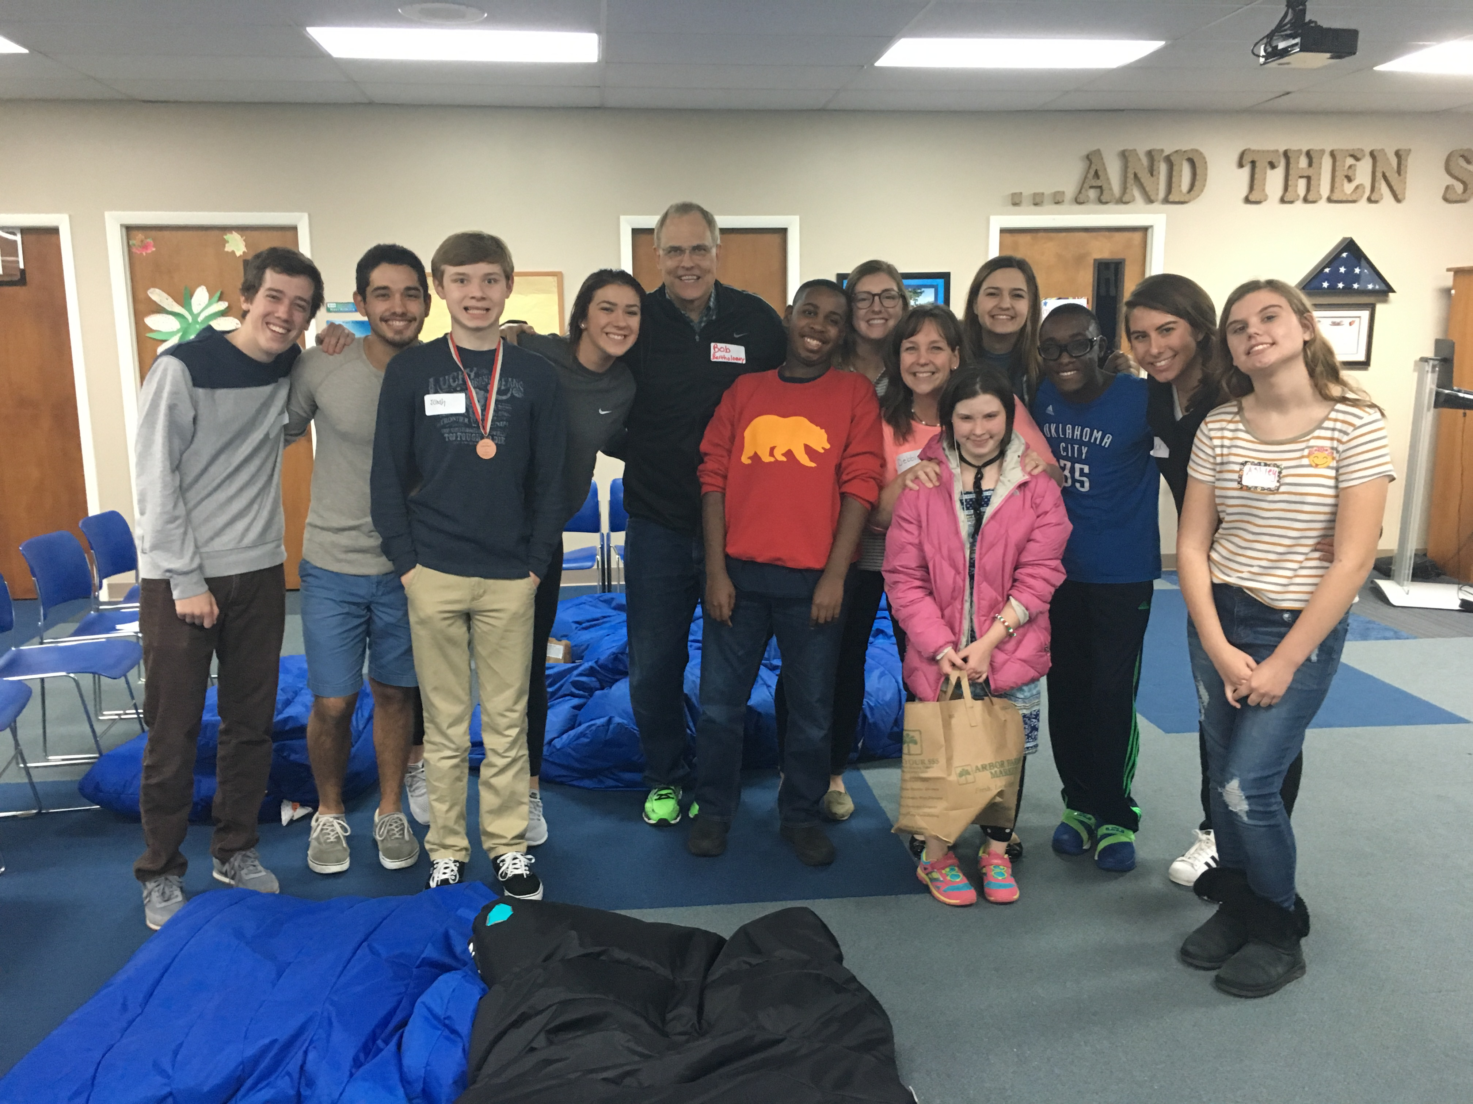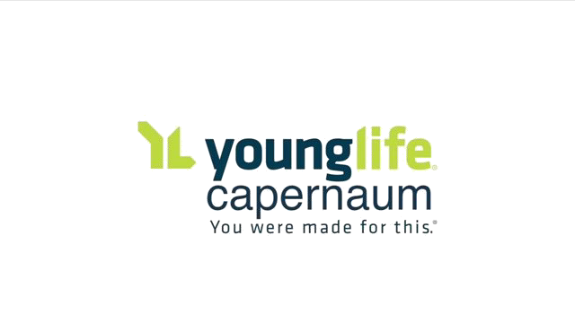

**Contact:** Caleb Lee at (248) 978-5911 **or** [salinecapernaum@gmail.com](mailto:salinecapernaum@gmail.com)

**For more information:**  Washtenawcounty.younglife.org or our Instagram @saline_capernaum

**Life Learning Community**

806 Airport Blvd, Ann Arbor, MI 48108

6:30-8:00 PM

**WHERE WE MEET**

Young Life Capernaum Ministries is a program of Young Life especially for high school teens and young adults up to age 26 with disabilities. Capernaum Club gives these young adults the chance to have fun, make friends, develop self-esteem, and learn more about Jesus.

**Capernaum Club** will include music, games, crafts, snacks, and talks about Jesus being our friend!

*Registration is mandatory at first event attended

**Spring 2017**

**YL Capernaum Dates**

**March-April**

**Tuesday, March 7th Capernaum Club**

**Week of March 13th Community Event TBD**

**Tuesday, March 21st**

**Capernaum Club**

**Tuesday, March 28th**

**Capernaum Club**

**Week of April 3rd**

**Spring Break- no events**

**Tuesday, April 11th**

**Community Event TBD**

**Tuesday, April 18th**

**Capernaum Club**

**All meeting times**

**6:30-8:00 PM**

**unless indicated** otherwise

**WHAT WE ARE**