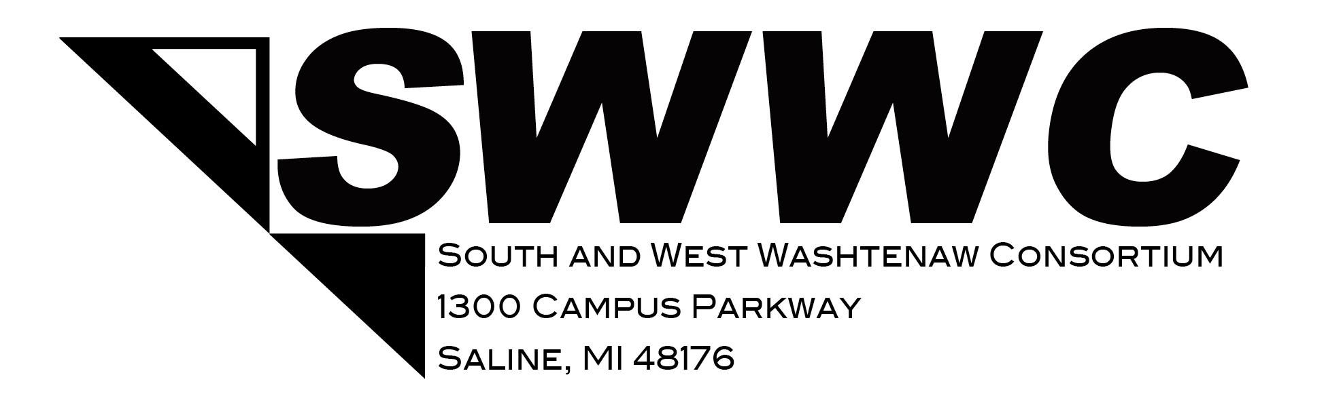

Qualifications for SWWC Program Admission

The South and West Washtenaw Staff is enthusiastic about training high school juniors and seniors for high wage, high skill and high demand occupations. To meet this national initiative, we take pride in an admission process that ensures that every application and applicant is thoroughly evaluated. Each student’s performance data is screened along with a teacher recommendation (Health Science and Cosmetology programs). If the number of applicants warrant, a staff-led student interview will take place at the home school. Also, if a student receives special education services, the Consortium’s Special Population Coordinator must attend the transition IEP meeting (springtime) to provide information to the student’s team, as well as share information back to the SWWC program instructor prior to an admissions decision. A lottery will then occur if there is an excessive number of students to the allowable enrollment.

Listed below is the student data that is needed:

- Completion of the on-line SWWC Application
- Student Attendance for the current school year. Additional information may be needed if there are more than 5 absences in a school year.
- Student GPA
- Student Disciplinary Record for the past two years
- Teacher Recommendation (current teacher) for specific programs
- Special Education Eligibility (accommodations)
- Student Essay
- Student Interview (all applicants will be interviewed if needed)

The Administration, Special Populations Coordinator and Instructional Staff look forward to instructing and assisting our collective students. If you have questions, comments or concerns please contact:

Jody Gielinski, SWWC Principal (734) 401-4371 gielinsj@salineschools.org

Mary Visel, Special Populations Coordinator (734) 401-4377 howleyvm@salineschools.org

